**Experiment No.: 1**

**Aim**

Install latest version of Ubuntu on a virtual box, set up a static IP address to it and install Drupal environment.

**Procedure**

Sudo



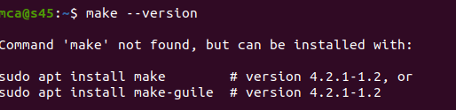

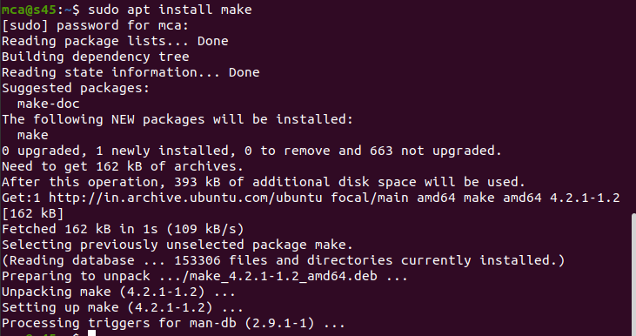

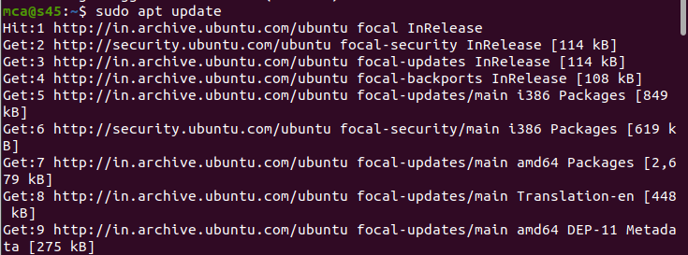

Make - -version

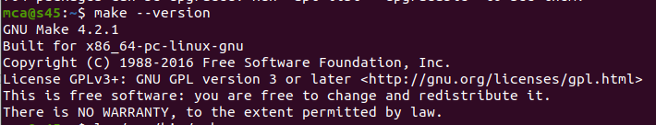

Make directory



If there is no such directory

Sudo apt install build-essential

Open vs code

Create folder

**Createfile named main.cpp**

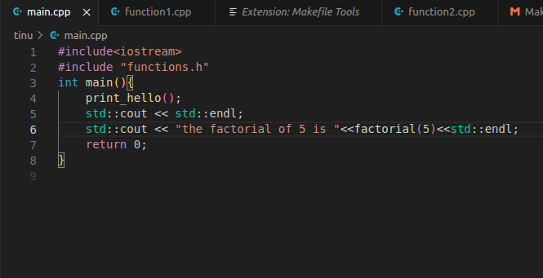

**Another file name function1.cpp**

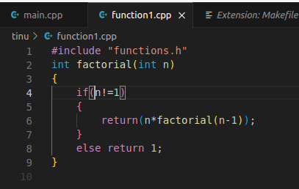

**Another file name function2.cpp**

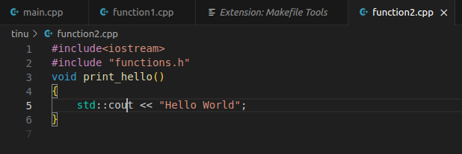

**Another file name functions.h**

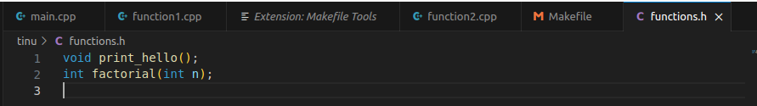

**Another file name Makefile**

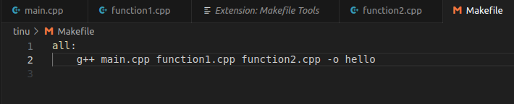

**Take extension and install Make file tools and Make**



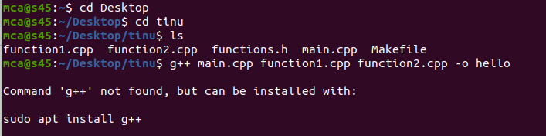

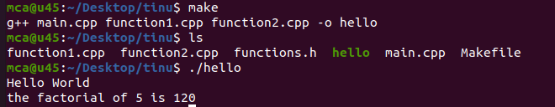

**CMAKE**





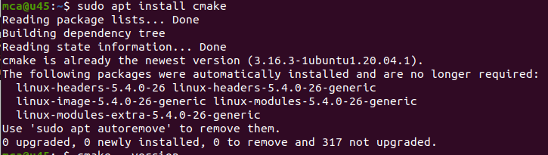

From extension,install cmake and cmake tools

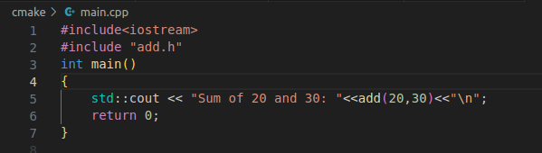

#include<iostream>

#include "add.h"

int main()

{

std::cout << "Sum of 20 and 30: "<<add(20,30)<<"\n";

return 0;

}

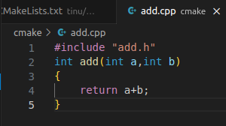

#include "add.h"

int add(int a,int b)

{

return a+b;

}

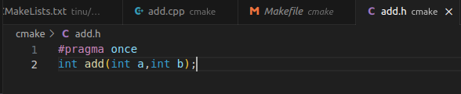

#pragma once

int add(int a,int b);

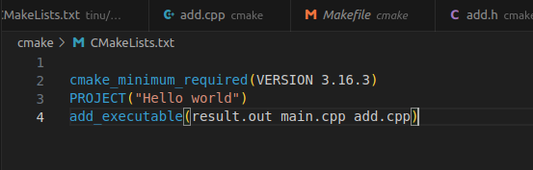

cmake_minimum_required(VERSION 3.16.3)

PROJECT("Hello world")

add_executable(result.out main.cpp add.cpp)





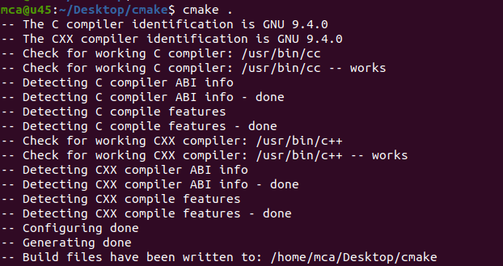

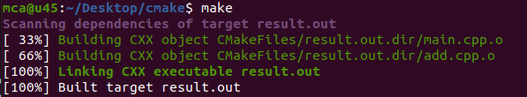



**Result:**

The program was executed and the result was successfully obtained. Thus CO was obtained.